

**JOB FAIR**

**February 8, 2018**

**9AM – 3PM**

**WALK-INS WELCOME!**

**MN Twins Target Field, 1 Twins Way, Minneapolis, MN**

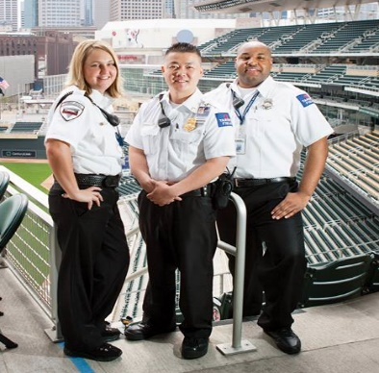

**Security Officers**

**Immediate Openings – FT or PT**

**General Security Services Corporation is seeking to Hire Security Officers to work out at Target Field during the MN Twins home game season, located in Minneapolis, MN**

**Use Parking Ramp A, take the Skyway**

**and you will be guided once in**

**$13.25 per hour**

**Responsibilities Include**

**Qualifications**

* Respond to all client concerns
* Perform rounds of facility
* Access control
* Provide escorts throughout the facility as needed
* Write Security and Incident reports
* Must be at least 18 years of age and have a HS Diploma or GED
* Pass a criminal background check
* Able to give clear directions in the event of an emergency
* Able to perform roving foot patrols
* Able to do extensive walking, sitting and/or stationary standing
* Able to push/pull an adult to safety
* Have an outgoing personality and critical thinking skills
* Able to work in a fast-paced environment
* Previous Security, Military, Law enforcement exp. Preferred
* Must be able to work between 6am and 12pm, hours will vary for each position

**We Offer**

* Paid Training
* Paid Bonuses
* Public Transportation Reimbursement
* Uniforms
* Medical/Dental/Life/Short Term Disability Benefits for FT employees
* 401(k)

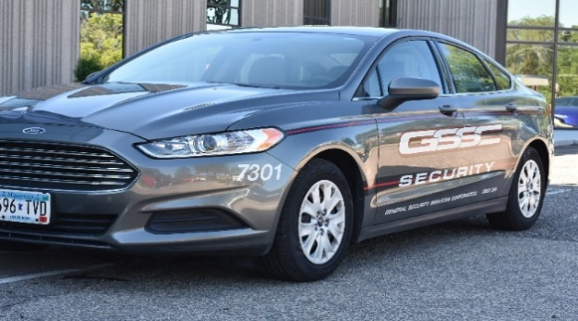

**Apply Today!**

If interested, please go to our website and complete the online application or stop and see us on February 8, 2018 at the MN Twins Target Field, Downtown Minneapolis

Or call 952-858-5094 for more information

Applying for position is not guaranteed hire

EOE/AA/Disability/Veterans/M/F Employer